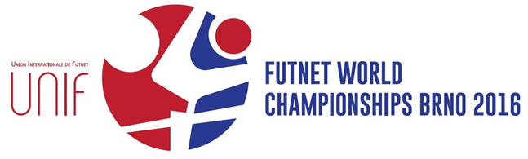
OFFICIAL DRAW

SINGLES – PARTICIPANTS
• Pots
– 1: Slovakia, Hungary, Czech Republic, France – 2: Switzerland, England, Canada, Romania
– 3: USA, Poland, Austria, Denmark
– 4: Costa Rica, Ukraine, Ireland, South Korea
– 5: Basque Country, Russia, Italy, Mali, Cameroon
25. 10. 2016 UNIF Futnet World Championships 2016 2
SINGLES – QUALIFICATION W X Y Z
DNK USA POL AUT IRL KOR UKR CRC
RUS ITA EUS CMR MLI
A B C D SVK FRA CZE HUN
CAN SUI ROU ENG T2 T1 U2 U1
SINGLES – BASIC GROUPS
DOUBLES – PARTICIPANTS
• Pots
– 1: Slovakia, South Korea, Hungary, Czech Republic – 2: Switzerland, France, USA, Romania
– 3: Ukraine, Poland, Canada, Austria
– 4: Costa Rica, Ireland, Denmark, Basque Country – 5: England, Russia, Italy, Mali, Cameroon
25. 10. 2016 UNIF Futnet World Championships 2016 5
DOUBLES – QUALIFICATION W X Y Z
AUT CAN UKR POL EUS IRL DNK CRC
CMR MLI ENG RUS ITA
A B C D SVK KOR HUN CZE
SUI FRA ROU USA T2 T1 U2 U1
DOUBLES – BASIC GROUPS
TRIPLES – PARTICIPANTS
• Pots
– 1: Slovakia, France, Hungary, Czech Republic – 2: Switzerland, South Korea, Poland, Romania
– 3: Ukraine, USA, Canada, Costa Rica
– 4: Austria, Ireland, Denmark, Basque Country – 5: England, Russia, Italy, Mali
25. 10. 2016 UNIF Futnet World Championships 2016 8
TRIPLES – QUALIFICATION W X Y Z
UKR CRC CAN USA AUT DNK EUS IRL ENG ITA RUS MLI
A B C D SVK FRA HUN CZE
SUI KOR POL ROU T2 T1 U2 U1
TRIPLES – BASIC GROUPS
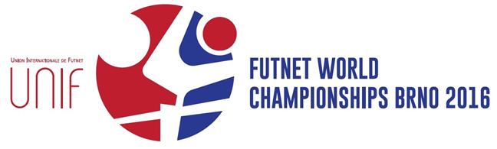
MORE INFORMATION
brno2016.worldfutnet.com

